XII International Physics Olympiad

Varna, Bulgaria, July 1981

The problems and the solutions are adapted by Miroslav Abrashev
University of Sofia, Faculty of Physics, 5 James Bourchier Blvd., 1164 Sofia, Bulgaria

Reference: O. F. Kabardin, V. A. Orlov, in “International Physics Olympiads for High School Students”, ed. V. G. Razumovski, Moscow, Nauka, 1985. (In Russian).

The Experimental Problem

Materials and Instruments: elastic rubber cord (the length of free cord is l₀ = 150 mm), vertically hanged up to a stand, set of weights from 10 g to 100 g, pan for the weights with mass 5 g, chronometer, ruler, millimeter (scaled) paper.
Note: The Earth Acceleration is g = 10 m/s². The mass of the rubber cord can be neglected.

Make the following study:
1. Load the rubber cord with weights in the range 15 g to 105 g. Put the data obtained into a table. Make a graph (using suitable scale) with the experimentally obtained dependence of the prolongation of the cord on the stress force F.
2. Using the experimental results, obtained in p.1, calculate and put into a table the volume of the cord as a function of the loading in the range 35 g to 95 g. Do the calculations consequently for each two adjacent values of the loading in this range. Write down the formulas you have used for the calculations. Make an analytical proposition about the dependence of the volume on the loading.
Assume that Young’s modulus is constant: E = 2.10⁶ Pa. Take in mind that the Hooke’s law is only approximately valid and the deviations from it can be up to 10%.
3. Determine the volume of the rubber cord, using the chronometer, at mass of the weight equal to 60 g. Write the formulas used.

Solution of the Experimental Problem

- The measurements of the cord length l_{n} at different loadings m_{n} must be at least 10.
The results are shown in Table I.

Table 1.
m_{n}, kg | F_{n} = m_{n}.g, N | l_{n}, mm | Δl_{n} = l_{n} – l₀, mm
0.005 | 0.05 | 153 | 3
0.015 | 0.15 | 158 | 8
0.025 | 0.25 | 164 | 14
0.035 | 0.35 | 172 | 22
0.045 | 0.45 | 181 | 31
0.055 | 0.55 | 191 | 41
0.065 | 0.65 | 202 | 53
0.075 | 0.75 | 215 | 65
0.085 | 0.85 | 228 | 78
0.095 | 0.95 | 243 | 93
0.105 | 10.5 | 261 | 111

The obtained dependence of the prolongation of the cord on the stress force F can be drawn on graph. It is shown in Fig. 1.
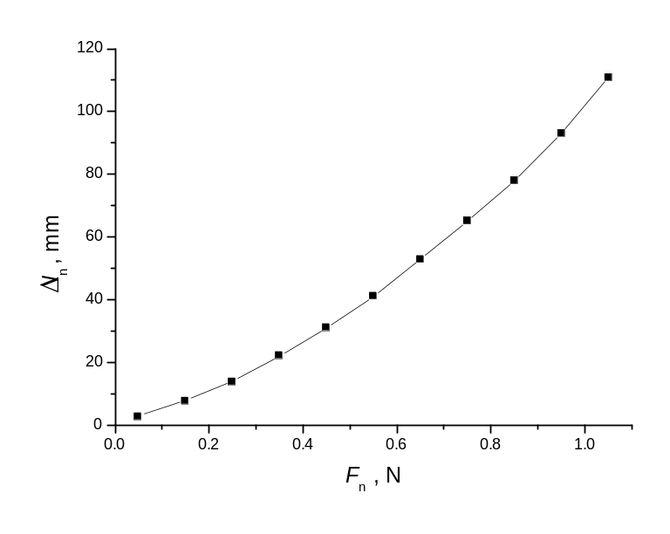
Fig.1

2.For the calculations of the volume the Hooke’s law can be used for each measurement:
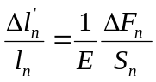,
therefore
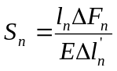,
where 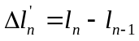, 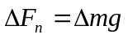. (Using the Hooke’s law in the form 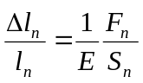leads to larger error, because the value of the 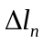is of the same order as l_{n}).
As the value of the S_{n} is determined, it is easy to calculate the volume V_{n} at each value of F_{n}:
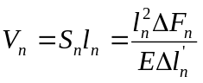.
Using the data from Table 1, all calculations can be presented in Table 2:

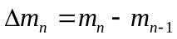, kg | 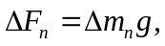N | l_{n} ,m | 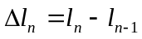, m | , m² | V_{n}=l_{n}S_{n}, m³
0.035 – 0.025 | 0.1 | 0.172 | 0.008 | 1,07.10⁻⁶ | 184.10⁻⁹
0.045 – 0.035 | 0.1 | 0.181 | 0.009 | 1,01.10⁻⁶ | 183.10⁻⁹
0.055 – 0.045 | 0.1 | 0.191 | 0.010 | 0,95.10⁻⁶ | 182.10⁻⁹
0.065 – 0.055 | 0.1 | 0.203 | 0.012 | 0,92.10⁻⁶ | 187.10⁻⁹
0.075 – 0.065 | 0.1 | 0.215 | 0.012 | 0,89.10⁻⁶ | 191.10⁻⁹
0.085 – 0.075 | 0.1 | 0.228 | 0.013 | 0,88.10⁻⁶ | 200.10⁻⁹
0.095 – 0.085 | 0.1 | 0.243 | 0.015 | 0,81.10⁻⁶ | 196.10⁻⁹
0.105 – 0.095 | 0.1 | 0.261 | 0.018 | 0,72.10⁻⁶ | 188.10⁻⁹

The results show that the relative deviation from the averaged value of the calculated values of the volume is:
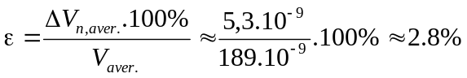
Therefore, the conclusion is that the volume of the rubber cord upon stretching is constant:
V_{n} = const.
3. The volume of the rubber cord at fixed loading can be determined investigating the small vibrations of the cord. The reason for these vibrations is the elastic force:
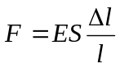
Using the second law of Newton:
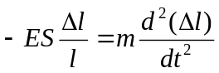,
the period of the vibrations can be determined:
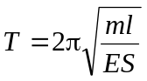.
Then
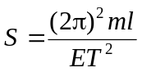,
and the volume of the cord is equal to:
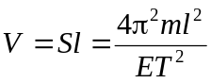
The measurement of the period gives: T = t/n = 5.25s /10 = 0.52 s at used mass m = 0.065 kg. The result for the volume V ≈ 195.10⁻⁹ m³, in agreement with the results obtained in part 2.

